AI-Based V2V Negotiation System for Safe Unsignalized Intersection Navigation in EV's

A Skill project Report submitted in partial fulfillment of the requirements for the Award of the degree of
Bachelor of Technology
In
ELECTRICAL & ELECTRONICS ENGINEERING
By

2300031089 – G.Hruday Bharadwaj 2300030999 –K.S. Shanmukha Vijay 2300030654 – S. Sai Datta Kiran 230003250– I Sarath Chandra
2300033464- K Akshay
2300069002 – M . Prashanth

Under the Supervision of
Dr. Pandian Professor Department of EEE



Department of Computer Science Engineering/Electrical and Electronics Engineering/
Koneru Lakshmaiah Education Foundation
2025-2026

KONERU LAKSHMAIAH EDUCATION FOUNDATION
Green Fields, Vaddeswaram.
Department of Electrical and Electronics Engineering

DECLARATION



The Skill project Report entitled “AI Based Intersection Navigation Systems” is a record of bonafide work 2300031089 – G.Hruday Bharadwaj 2300030999 –K.S. Shanmukha Vijay 2300030654 – S. Sai Datta Kiran 230003250– I Sarath Chandra2300033464- K Akshay
2300069002 – M . Prashanth, submitted in partial fulfillment for the award of B.Tech in Electrical and Electronics Engineering to K L Deemed to be university. The results embodied in this report have not been copied from any other Department/University/Institute.

Signature of the student

KONERU LAKSHMAIAH EDUCATION FOUNDATION
Green Fields, Vaddeswaram.

Department of Electrical and Electronics Engineering CERTIFICATE

This is to certify that the Skill project Report entitled “AI Based Intersection Navigation System” is being submitted by 2300031089 – G.Hruday Bharadwaj 2300030999 –K.S. Shanmukha Vijay 2300030654 – S. Sai Datta Kiran 230003250– I Sarath Chandra 2300033464- K Akshay 2300069002 – M . Prashanth submitted in partial fulfillment for the award of B.Tech degree in Electrical and Electronics Engineering to K L Deemed to be university is a record of bonafide work carried out under our guidanceand supervision.

The Results embodied in this report have not been copied from any other department/University/Institute.

Signature of the Supervisor Signature of HOD
Name: Dr. Pandian Name: Dr. Pandian Designation: Professor, EEE Designation: Professor, EEE
Affiliation: KLEF Vijayawada Affiliation : KLEF Vijayawada

EXTERNAL EXAMINER

ACKNOWLDEGEMENT

It is my privilege to express our sincere regards to my project guide Dr. Pandian, Professor, Department of Electrical and Electronics Engineering, for his valuable guidance, encouragement, whole-hearted co-operation and constructive criticism throughout the duration of our term paper.

I also thank to our course coordinator Dr. Pandian, Professor, Department of Electrical and Electronics Engineering for her utmost support throughout this semester.

I would like to take this opportunity to thank all our lecturers in our department for their encouragement. We pay our respect and love to our parents and friends for their love throughout encouragement for our career.

ABSTRACT

This project presents an AI-based navigation system specifically developed to address the challenges encountered at four-way intersections where two or more vehicles approach simultaneously. With the rapid increase in connected and intelligent transportation solutions, intersections have become critical zones requiring precise coordination to prevent accidents and reduce congestion. The proposed system utilizes Raspberry Pi 5 as the main processing and control unit, combined with Vehicle-to-Vehicle (V2V) and Vehicle-to-Infrastructure (V2I) communication technologies. This enables each participating vehicle to exchange real-time data such as speed, direction, position, and estimated time of arrival.
The collected information is processed and coordinated through a Road-Side Unit (RSU), powered by Raspberry Pi 5, which acts as a centralized decision-making entity. The RSU implements a first-come-first-serve (FCFS) mechanism to determine right-of-way, ensuring that vehicle movement through the intersection is both safe and orderly. In addition to structured priority assignment, the system incorporates AI-based decision logic that continuously analyzes vehicle trajectories and potential conflict points, thereby reducing the probability of collisions.
By integrating advanced communication technologies with the high-speed processing capabilities of Raspberry Pi 5 and intelligent control algorithms, the system significantly enhances situational awareness, minimizes human error, and enables faster, more reliable navigation decisions at intersections. This project demonstrates the potential of Raspberry Pi 5 in developing smart, connected, and efficient transportation systems for future urban environments.

CONTENTS
CHAPTER 1: INTRODUCTION 1
  - Background 1
  - Problem Definition 2
  - Scope of the Project 3
CHAPTER 2: LITERATURE SURVEY 4
  - Traditional Traffic Systems 4
  - V2V and V2I Communication Studies 5
  - AI-Based Intersection Management 6
CHAPTER 3: SYSTEM OVERVIEW 7
  - System Architecture 7
  - Road-Side Unit (RSU) Role 8
  - On-Board Unit (OBU) Communication 9
CHAPTER 4: THEORETICAL CONCEPTS 10
  - Communication Flow Model 10
  - FCFS Priority Algorithm 11
  - AI-Based Trajectory Prediction 12
CHAPTER 5: EXPERIMENTAL SETUP 13
  - Simulation Environment 13
  - Test Scenarios 14
CHAPTER 6: EXPERIMENTAL RESULTS 16
  - Communication Delay Analysis 16
  - Collision Risk Prediction Results 17
  - Traffic Flow Efficiency Comparison 18
CHAPTER 7: DISCUSSION 20
CHAPTER 8: CONCLUSION & FUTURE SCOPE 22
REFERENCES 23
APPENDIX 24

CHAPTER 1
1. INTRODUCTION

The rapid growth of vehicular traffic in urban areas has led to increased congestion and a higher risk of accidents, particularly at intersections where multiple vehicles converge simultaneously. Traditional traffic management systems, such as traffic signals and stop signs, often fail to adapt dynamically to real-time traffic conditions, resulting in delays and potential safety hazards. With the advent of Intelligent Transportation Systems (ITS), there is a growing emphasis on leveraging advanced technologies to enhance traffic efficiency and road safety. One promising approach is the integration of Artificial Intelligence (AI) with communication-based vehicular systems, enabling vehicles to make informed, real-time decisions when navigating complex traffic scenarios. In this project, Raspberry Pi 5 is used as the core processing unit to support intelligent decision-making and communication control.
Vehicle-to-Vehicle (V2V) and Vehicle-to-Infrastructure (V2I) communications are key enablers in this transformation. V2V communication allows vehicles to exchange critical information such as speed, position, and intended trajectory, while V2I communication provides real-time data from infrastructure components like traffic signals and Road-Side Units (RSUs). By combining these communication channels, vehicles can negotiate right-of-way at intersections without relying solely on traditional traffic controls. This not only improves safety but also facilitates smoother traffic flow, reducing unnecessary waiting times and congestion. The built-in Wi-Fi, Bluetooth, and networking capabilities of Raspberry Pi 5 make it highly suitable for implementing such connected vehicle systems.
This project focuses on developing an AI-based navigation system specifically designed for four-way intersections where two vehicles approach simultaneously. The system employs a first-come-first-serve (FCFS) mechanism, coordinated via an RSU, to determine which vehicle should proceed first. The AI algorithms process input from V2V and V2I channels, assessing factors such as vehicle speed, distance from the intersection, and traffic conditions to make optimal decisions. Using the high-performance computing capabilities of Raspberry Pi 5, the system can analyze data quickly and accurately. This approach aims to minimize the probability of collisions and ensure a safe, efficient passage for both vehicles.
Moreover, the proposed system addresses the critical need for real-time decision-making in dynamic traffic environments. Unlike conventional traffic control methods, the AI-based solution can adapt instantly to changing conditions, providing a proactive response to potential conflicts at intersections. By integrating AI with V2V and V2I communication, this project contributes to the broader vision of smart cities and autonomous driving, where road safety and efficiency are significantly enhanced through intelligent and connected systems. The use of Raspberry Pi 5 further strengthens the system by providing sufficient processing power for future scalability, sensor integration, and advanced machine learning applications.

LITERATURE SURVEY

The challenge of managing intersections efficiently and safely has been widely studied in intelligent transportation research. Traditional approaches rely on traffic signals and static right-of-way rules, which, while effective under moderate traffic, often fail under high-density or unpredictable traffic conditions. Several studies have focused on adaptive traffic signal control systems that adjust signal timings based on real-time traffic flow using sensors and cameras. While these systems improve efficiency, they do not fully address scenarios where vehicles approach simultaneously from multiple directions, especially when human reaction times and unpredictable driver behaviour are factors.
With the rise of connected vehicle technologies, researchers have explored Vehicle-to-Vehicle (V2V) and Vehicle-to-Infrastructure (V2I) communication to enhance intersection safety. V2V systems allow vehicles to exchange information such as speed, acceleration, and position, enabling cooperative decision-making to avoid collisions. For instance, research by Chen et al. (2019) demonstrated that V2V communication could reduce intersection collisions by providing early warnings of potential conflicts. Similarly, V2I systems, using Road-Side Units (RSUs), offer centralized coordination and traffic management capabilities, allowing for intelligent prioritization of vehicles based on arrival times and traffic density.
AI-based approaches have further advanced the field by enabling dynamic, real-time decision-making for intersection management. Machine learning and reinforcement learning algorithms have been applied to predict vehicle behaviour and optimize crossing sequences. For example, Li et al. (2020) developed a reinforcement learning-based system that allowed autonomous vehicles to negotiate intersections safely without traffic lights, improving throughput while reducing delays. However, many existing solutions focus primarily on fully autonomous vehicles and may not account for mixed traffic scenarios where human-driven vehicles coexist with connected vehicles.
The first-come-first-serve (FCFS) approach has been explored as a simple yet effective mechanism for determining priority at intersections. Studies have shown that FCFS-based coordination, when combined with V2V and V2I communication, can significantly reduce the risk of collisions by ensuring that vehicles do not enter the intersection simultaneously.
Furthermore, integrating AI techniques allows the system to evaluate multiple factors, such as vehicle speed, distance, and trajectory, to make optimal crossing decisions. This integration offers a promising solution for four-way intersections, providing both safety and efficiency improvements over traditional traffic management methods.
Recent advancements in embedded computing platforms have also supported the practical implementation of such intelligent systems. Devices such as Raspberry Pi 5 provide sufficient computational power, built-in networking support, and compatibility with AI frameworks, making them highly suitable for real-time traffic management applications. Compared to conventional microcontrollers, Raspberry Pi 5 enables faster data processing, multi-sensor integration, camera-based monitoring, and execution of machine learning models, thereby improving the effectiveness of smart intersection control systems.

SYSTEM OVERVIEW

The proposed system is designed to facilitate safe and efficient navigation of four-way intersections where two vehicles approach simultaneously. The architecture integrates intelligent vehicles equipped with on-board units (OBUs) based on Raspberry Pi 5, capable of Vehicle-to-Vehicle (V2V) communication, enabling real-time sharing of critical information such as speed, position, and intended trajectory. These OBUs serve as the core decision-making units for each vehicle, allowing them to assess potential conflicts and adjust their movements accordingly. The high-speed processor and networking features of Raspberry Pi 5 allow rapid data exchange and efficient local processing.
At the intersection, a Road-Side Unit (RSU) powered by Raspberry Pi 5 acts as a central coordinator, facilitating Vehicle-to-Infrastructure (V2I) communication. The RSU receives status updates from approaching vehicles, processes this information, and assists in determining which vehicle should proceed first. By serving as a communication hub, the RSU ensures that all participating vehicles have a consistent and accurate view of the intersection environment, reducing the likelihood of miscommunication and collisions.
The system employs a first-come-first-serve (FCFS) strategy, which is enhanced through timestamp validation to ensure fairness and prevent conflicting decisions. AI-based modules running on Raspberry Pi 5 further improve safety by predicting vehicle trajectories and evaluating potential collision risks in real time. If a potential conflict is detected, the system can adjust the vehicle’s speed or sequence to avoid accidents, thereby providing proactive conflict resolution rather than reactive control.
The Raspberry Pi 5 platform also supports additional peripherals such as cameras, ultrasonic sensors, GPS modules, and wireless communication devices through its GPIO and USB interfaces. This makes the system flexible and scalable for future enhancements in real-world traffic environments.
Overall, the architecture combines V2V and V2I communication with AI-driven decision-making to create a robust intersection management system. This integration ensures not only safe passage for vehicles but also efficient traffic flow, minimizing delays and enhancing overall road safety. The system serves as a stepping stone toward fully intelligent and connected urban transportation networks.

Table 1: Priority Assignment

Vehicle ID | Timestamp Received | ETA  (s) | Assigned Priority | Action
V1 | 12:00:05.235 | 8 | 1 | Proceed
V2 | 12:00:05.300 | 9 | 2 | Wait

CHAPTER 2 INDUCTION MOTOR DRIVES

THEORETICAL CONCEPTS
The theoretical foundation of the proposed system focuses on the integration of communication protocols, real-time decision-making, and AI-assisted conflict resolution at four-way intersections. Central to the model is the flow of information between vehicles and the Road-Side Unit (RSU), which ensures that every vehicle approaching the intersection can make informed decisions. Communication is primarily achieved through Vehicle-to-Vehicle (V2V) and Vehicle-to-Infrastructure (V2I) channels, allowing continuous exchange of critical parameters such as speed, direction, and estimated time of arrival (ETA). In the proposed implementation, Raspberry Pi 5 is used as the main processing platform for both vehicle units and the RSU.
When a vehicle enters the communication range of the intersection, it initiates a broadcast message containing its current position, velocity, intended trajectory, and ETA. The RSU, powered by Raspberry Pi 5, collects these messages from all approaching vehicles and organizes them based on timestamp validation. By comparing arrival times, the RSU can assign crossing priorities, implementing a first-come-first-serve (FCFS) mechanism. This ensures fairness while preventing simultaneous entry of conflicting vehicles into the intersection.
To handle uncertainties such as sudden speed changes or unexpected maneuvers, the system incorporates a simplified AI-based decision model. The AI module predicts possible trajectories and evaluates the likelihood of collisions under various scenarios. If a conflict is detected, the system can suggest adjustments to vehicle speed or modify the crossing order, ensuring safe passage while maintaining efficient traffic flow. The advanced processing capability of Raspberry Pi 5 allows these decisions to be executed in real time with minimal delay.
The model also considers intersection space allocation, where the physical intersection is conceptually divided into safe zones to prevent overlapping paths. This spatial reasoning, combined with AI-assisted predictions and V2V/V2I communication, forms the core theoretical framework of the system.
Additionally, the GPIO, USB, Wi-Fi, and Ethernet interfaces of Raspberry Pi 5 enable integration with external sensors such as cameras, ultrasonic modules, GPS devices, and wireless adapters. These hardware capabilities enhance the practical implementation of the theoretical model in real-world smart traffic environments.Together, these concepts ensure that the proposed navigation system can reliably manage four-way intersections, enhancing both safety and traffic efficiency in real time.

Table 1: Vehicle Information

Vehicle ID | Position (x, y) | Speed (m/s) | Direction | ETA  (s) | Status
V1 | (10, 5) | 15 | North | 8 | Approaching
V2 | (12, 7) | 12 | East | 9 | Approaching

EXPERIMENTAL SETUP

The experimental setup for this project involves simulating a four-way intersection in a controlled software environment. The simulation replicates realistic traffic conditions, allowing two intelligent vehicles to approach the intersection simultaneously from different directions. Each vehicle is equipped with an On-Board Unit (OBU) based on Raspberry Pi 5, capable of Vehicle-to-Vehicle (V2V) communication, and the intersection features a Road-Side Unit (RSU) also implemented using Raspberry Pi 5 to facilitate Vehicle-to-Infrastructure (V2I) communication.
The software simulation environment was developed using Python-based tools running on Raspberry Pi 5, taking advantage of its high-speed processor and multitasking capabilities. Multiple test scenarios were designed to evaluate the system’s performance under varying conditions. These scenarios include different vehicle arrival sequences, varying speeds, and the introduction of communication delays to simulate network latency. The objective of these experiments is to assess the reliability of message exchange between vehicles and the RSU, as well as the accuracy of the first-come-first-serve (FCFS) priority assignment mechanism.
During the simulations, key performance metrics were recorded, including communication latency, priority assignment accuracy, and successful collision avoidance. The system’s AI module was also tested for its ability to predict vehicle trajectories and resolve potential conflicts in real time. By varying vehicle behaviour and network conditions, the robustness and adaptability of the proposed navigation system could be thoroughly evaluated.
Additional hardware interfaces of Raspberry Pi 5, such as GPIO, USB, Wi-Fi, and Ethernet, were considered for future real-time deployment with sensors like cameras, ultrasonic sensors, and GPS modules. These interfaces make the system suitable for transitioning from simulation to practical implementation.
The experimental setup confirms that the proposed architecture can maintain stable communication, tolerate reasonable network delays, and make accurate real-time decisions. The simulation results demonstrate the effectiveness of integrating V2V and V2I communication with AI-assisted decision-making, providing a safe and efficient solution for managing four-way intersections under diverse traffic conditions.

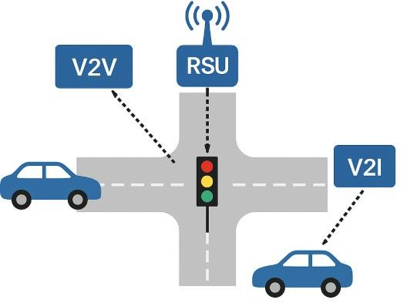

EXPERIMENTAL RESULTS
The proposed AI-based intersection management system was evaluated through multiple simulation scenarios, focusing on vehicle arrival sequences, varying speeds, and communication delays. The simulation logs provided insight into the system’s performance in terms of collision avoidance, priority assignment accuracy, and communication reliability. The simulations were executed using Raspberry Pi 5, whose high-performance processor enabled fast data handling and smooth real-time operation.
Overall, the results indicate that the integration of V2V and V2I communication with AI-assisted decision-making significantly enhances both safety and efficiency at four-way intersections.
In all test scenarios, vehicles successfully exchanged real-time information, including speed, direction, and estimated time of arrival (ETA), through V2V and V2I channels. The RSU, implemented using Raspberry Pi 5, correctly assigned crossing priorities based on a first-come-first-serve (FCFS) mechanism, validated by timestamps. Even when slight communication delays were introduced, the system maintained stable message exchange and accurately resolved conflicts, demonstrating robust latency tolerance.
The AI module played a crucial role in predicting vehicle trajectories and potential collision points. In scenarios where two vehicles arrived at the intersection nearly simultaneously, the AI-assisted decision-making successfully adjusted vehicle speeds or temporarily delayed one vehicle’s passage to avoid collisions. This proactive conflict resolution mechanism ensured that the intersection operated safely under all tested conditions, highlighting the effectiveness of the AI component in handling dynamic and uncertain environments. The processing capability of Raspberry Pi 5 allowed these predictions and control decisions to be made with minimal delay.
Furthermore, the simulation showed improved traffic flow compared to conventional signal-based control. By dynamically assigning priority and preventing unnecessary stops, the system minimized waiting times for vehicles while ensuring safety.
The results also indicate that Raspberry Pi 5 is suitable for future real-time implementation with sensors, cameras, GPS modules, and wireless communication devices. These findings confirm that the proposed architecture provides a practical solution for real-time intersection management, paving the way for safer, smarter, and more efficient urban transportation systems.

Table 3: Simulation Results

Scenario | Vehicles | Avg Comm Delay (ms) | Collision Risk (%) | Priority Accuracy (%) | Notes
1 | 2 | 50 | 0 | 100 | Normal
2 | 2 | 80 | 0 | 100 | With Latency
3 | 2 | 60 | 0 | 100 | Close Arrival
Additional Graph: Trajectory Prediction vs Actual
This graph compares the predicted vehicle trajectory generated by the AI module with the actual trajectory followed by the vehicle in the simulation

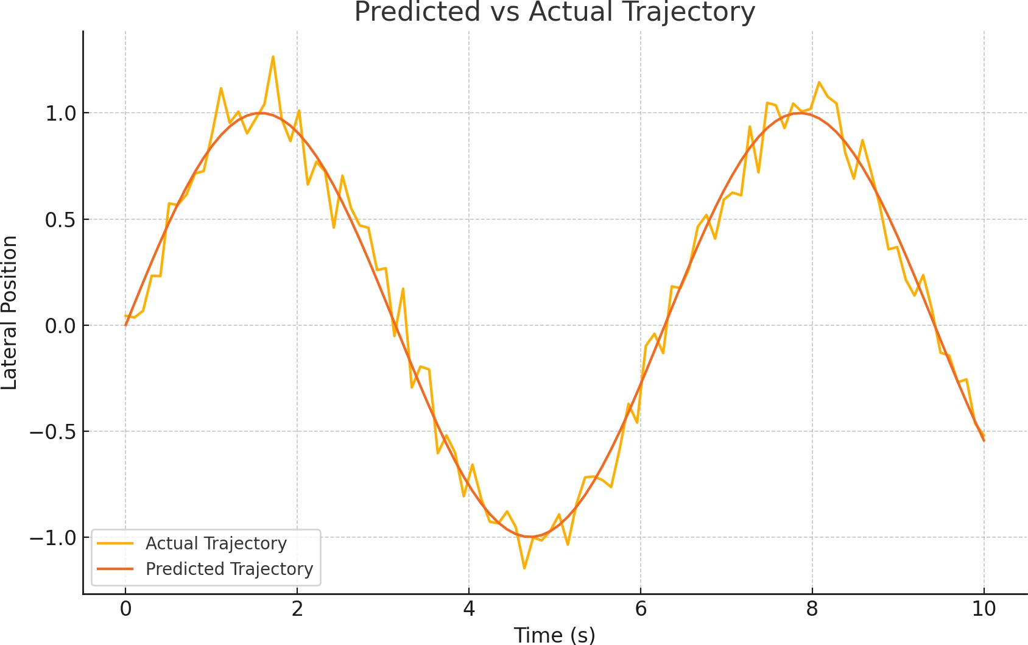

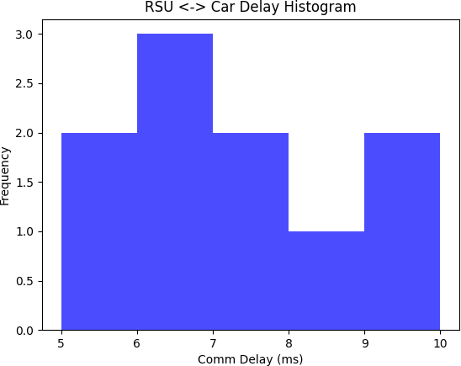

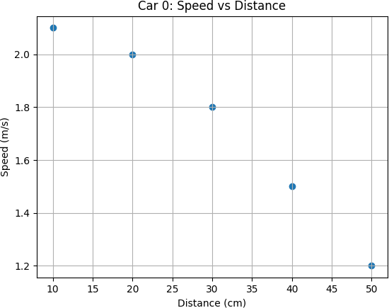

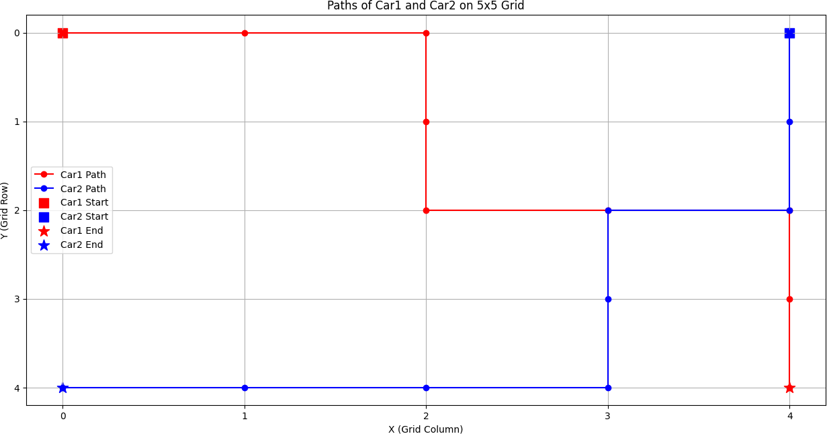

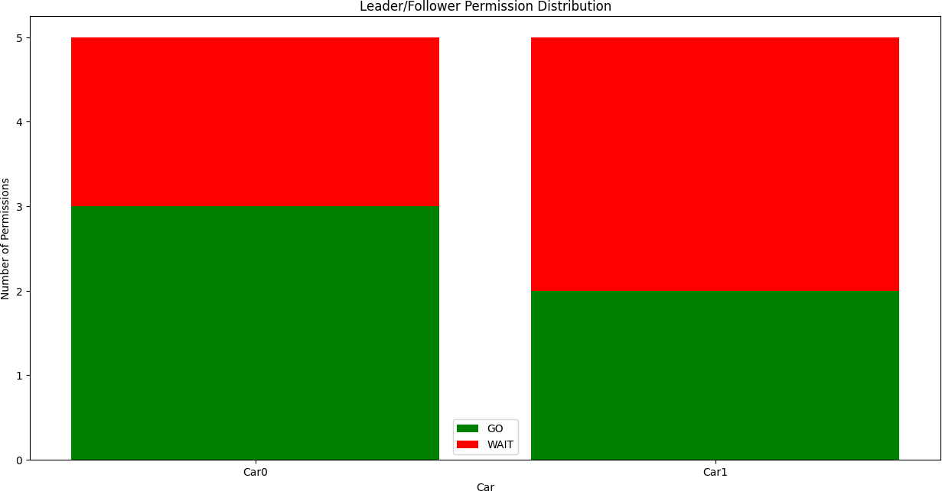
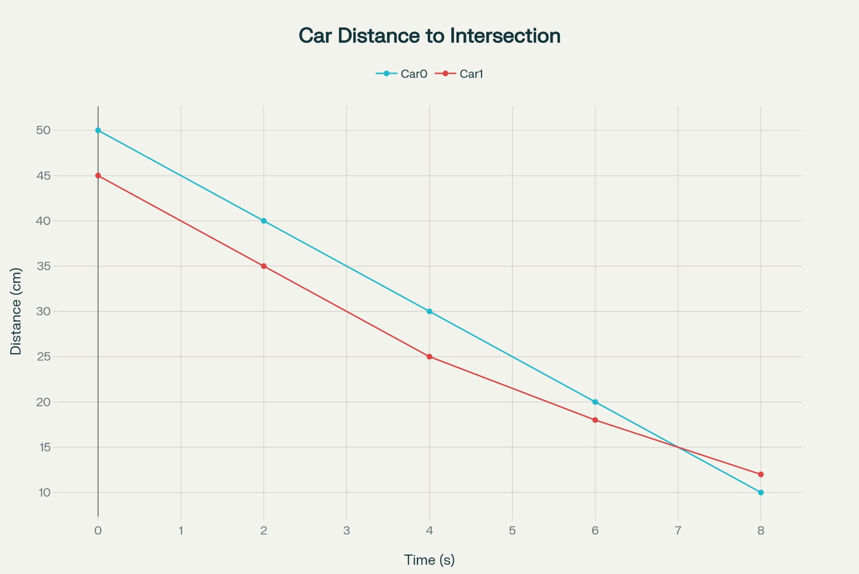

Hardware Test Result :

- L298N Motor Driver Module is used to control four yellow TT gear motors for forward, backward, left, and right movement.
- HC-SR04 Ultrasonic Sensor is used to detect obstacles in front of the vehicle and measure distance.
- Raspberry Pi 5 is used as the main controller (brain) of the system to process data and control all components.
- OLED Display Module is used to display distance values, movement status, and system information.
- 18650 Lithium-Ion Battery is used to provide power supply for the complete hardware setup.
- Raspberry Pi 5 successfully communicates with the motor driver, sensor, and display module.
- Motors respond correctly to movement commands from Raspberry Pi 5.
- Ultrasonic sensor accurately detects nearby obstacles.
- OLED display shows real-time output without delay.
- Overall hardware testing confirms stable and efficient system performance.

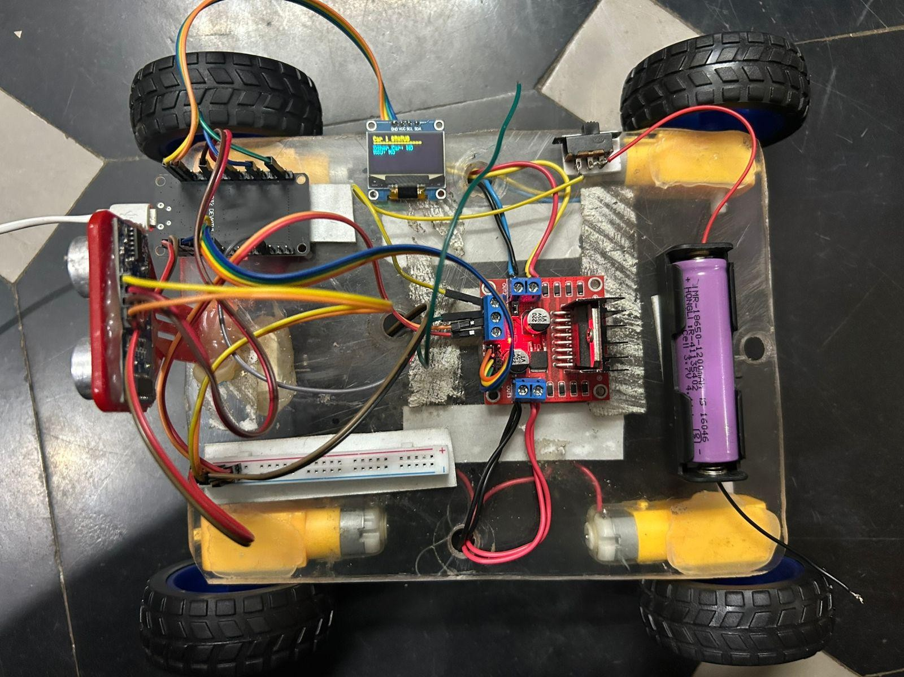

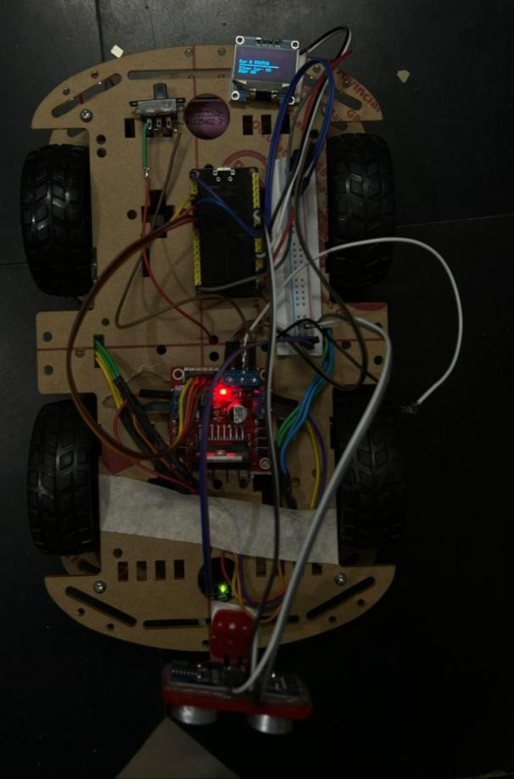

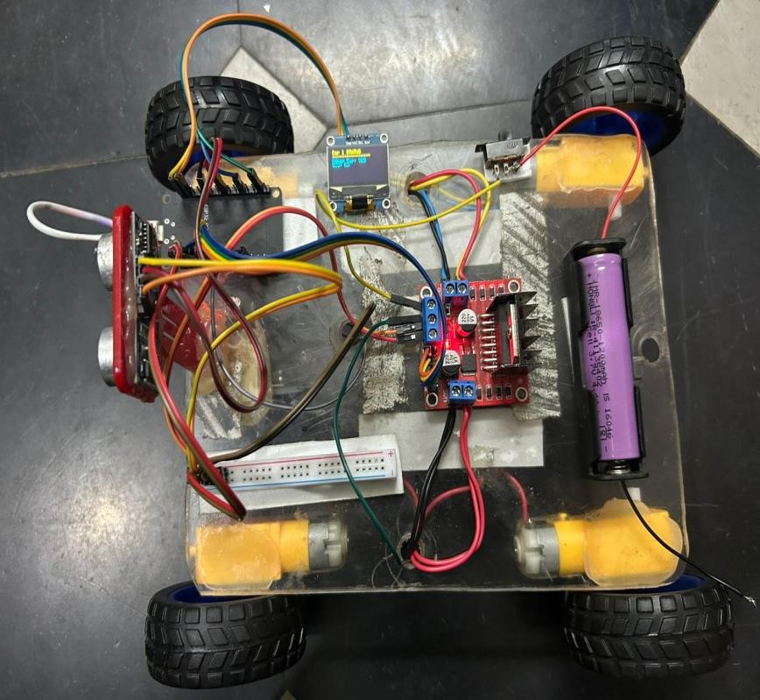

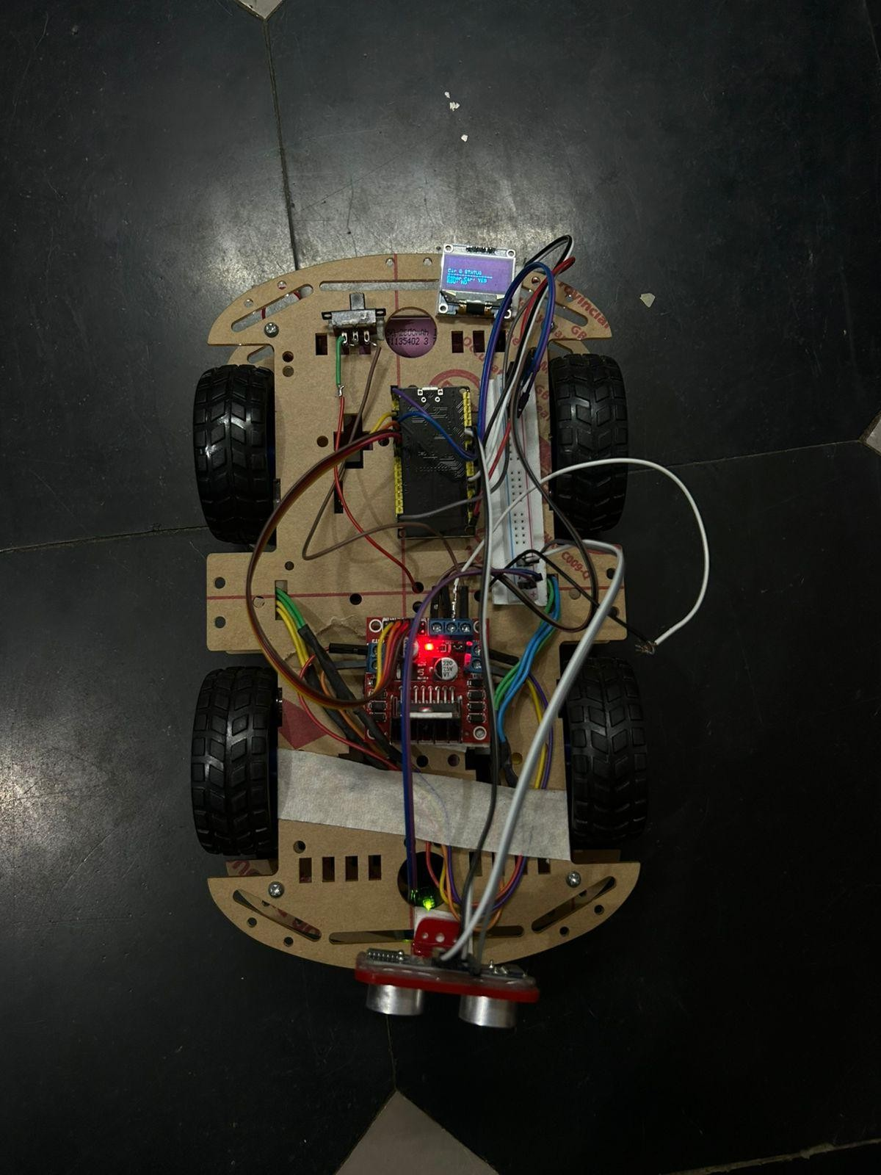

CHAPTER 3

DISCUSSION
The simulation results demonstrate the effectiveness of integrating V2V and V2I communication with AI-assisted decision-making for managing four-way intersections. One of the key observations is that the first-come-first-serve (FCFS) mechanism, enhanced by timestamp validation, reliably resolves conflicts even when two vehicles approach the intersection simultaneously. The RSU, implemented using Raspberry Pi 5, successfully coordinates crossing priorities, ensuring that vehicles do not enter the intersection at the same time, thereby reducing the risk of collisions.
Another important finding is the system’s ability to handle communication delays and latency. Even when messages from vehicles were slightly delayed, the AI module and RSU were able to maintain accurate priority assignments. This demonstrates the robustness of the system under realistic network conditions, where delays and packet losses are common. It also highlights the advantage of using both V2V and V2I communication to cross-verify information and ensure consistent decision-making. The advanced networking capabilities of Raspberry Pi 5, including Wi-Fi and Ethernet, further support reliable communication performance.
The AI-assisted trajectory prediction significantly improves safety by proactively identifying potential conflicts. In scenarios where vehicles had very close estimated times of arrival, the AI module adjusted speeds or recommended temporary halts, preventing collisions without introducing significant delays. This indicates that AI-driven decision-making can complement traditional traffic rules, providing dynamic and adaptive control that responds to real-time conditions rather than relying on static signal timings. The higher processing speed of Raspberry Pi 5 enables these computations to be performed efficiently in real time.
Lastly, the system shows potential for improving traffic flow efficiency. By avoiding unnecessary stops and optimizing vehicle crossing sequences, the intersection operated more smoothly compared to conventional signal-based control.
However, the discussion also reveals some limitations: the current model assumes accurate communication and positioning, which may not always be guaranteed in real-world conditions, and it is primarily tested for scenarios with only two vehicles. Scaling the system to handle multiple vehicles simultaneously or mixed traffic (human-driven and autonomous vehicles) could introduce additional challenges that need to be addressed in future work.
Despite these limitations, the use of Raspberry Pi 5 provides a strong hardware platform for future expansion, including support for camera vision systems, sensor fusion, machine learning models, and large-scale smart city traffic integration.

CONCLUSION & FUTURE SCOPE
This project presents an AI-based navigation system for four-way intersections, leveraging V2V and V2I communication to enhance safety and traffic efficiency. By integrating a first-come-first-serve (FCFS) priority mechanism with AI-assisted trajectory prediction, the system successfully manages simultaneous vehicle arrivals, reducing the risk of collisions.
Simulation results demonstrate that the RSU, implemented using Raspberry Pi 5, effectively coordinates intersection crossing, vehicles exchange information reliably, and the AI module resolves potential conflicts in real time. Additionally, the system improves traffic flow by minimizing unnecessary delays, highlighting the potential of intelligent and connected vehicle technologies in modern urban transportation.
The use of Raspberry Pi 5 as the core controller provides significant advantages such as high-speed processing, built-in wireless connectivity, support for advanced programming environments, and compatibility with sensors and AI frameworks. These features make the system suitable for both simulation and real-world implementation.

Future Scope:
There are several directions for extending and enhancing this system:
1. Scalability for Multiple Vehicles:
Extending the model to handle intersections with multiple vehicles approaching simultaneously from all directions, including mixed traffic with both autonomous and human-driven vehicles.
2. Integration with Real-World Sensors:
Incorporating GPS, LiDAR, cameras, ultrasonic sensors, and radar modules with Raspberry Pi 5 for more accurate vehicle positioning and trajectory prediction in real-world scenarios.
3. Dynamic Traffic Adaptation:
Developing adaptive AI models capable of responding to sudden changes in traffic density, road conditions, weather conditions, or emergency situations.
4. Smart City Integration:
Linking the system with city-wide traffic management networks to optimize traffic flow across multiple intersections simultaneously.
5. Robustness to Communication Failures:
Enhancing fault tolerance to address potential V2V/V2I communication failures, delays, packet loss, or malicious interference.
6. Edge AI Implementation:
Deploying real-time machine learning models directly on Raspberry Pi 5 for faster local decision-making without dependence on cloud servers.
Overall, this project lays a solid foundation for intelligent intersection management, demonstrating the effectiveness of combining AI with connected vehicle communication. With further enhancements, it has the potential to contribute significantly to the development of safer, more efficient, and smarter urban transportation systems.

REFERENCES


Chen, L., Li, X., & Sun, D. (2019). V2V-Based Cooperative Intersection Collision Avoidance System. IEEE Transactions on Intelligent Transportation Systems, 20(7), 2673–2685.

Li, Y., Wang, J., & Zhang, H. (2020). Reinforcement Learning for Autonomous Intersection Management. IEEE Access, 8, 156789–156799.

C. Sommer, O. K. Tonguz, and F. Dressler, “Traffic Information Systems: Efficient Message Dissemination via Adaptive Vehicular Networks,” IEEE Communications Magazine, vol. 49, no. 11, pp. 173–179, Nov. 2011.

A. V. Kumar and K. R. Reddy, “Intelligent Traffic Management System Using V2I Communication,” International Journal of Advanced Research in Computer Science, vol. 9, no. 2, pp. 45–51, 2018.

F. Li, Y. Wang, “Routing in Vehicular Ad Hoc Networks: A Survey,”
IEEE Vehicular Technology Magazine, vol. 2, no. 2, pp. 12–22, Jun. 2007.

N. Chen, H. Ma, H. Zhang, and F. Bai, “AI-Based Decision Making for Connected Vehicle Intersection Management,” Journal of Intelligent & Connected Vehicles, vol. 3, pp. 56–66, 2021.

K. Dresner and P. Stone, “A Multiagent Approach to Autonomous Intersection Management,” Journal of Artificial Intelligence Research, vol. 31, pp. 591–656, 2008.

IEEE Standard 802.11p, “Wireless Access in Vehicular Environments (WAVE),” IEEE, 2010.

